**Impacts Models and justification of (some) contribution values**

Please find below the impact model diagrams, and a brief description/justification of the weights we felt were not intuitively obvious.

1. **Decrease Cost**

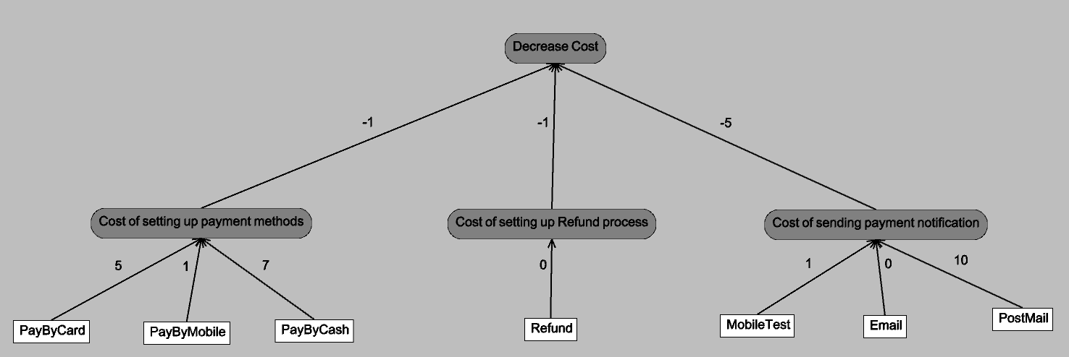

The cost of setting up a payment method and refund process (validating cause of refund, confirming refund method etc.) is a one-time cost, as opposed to the recurring cost of sending out payment notification. Thus, weights are -1 and -5 respectively. Also, for card payment, we need to buy a machine to read the card, for cash payment we need a cash register and cashier, and wallet payment requires only an app. Sending out an e-mail is free, text is marginal cost, but post is pretty expensive. The actual process of refund should not add any cost to the model, hence it’s assigned 0 weight.

1. **Decrease TimeOfOperation**

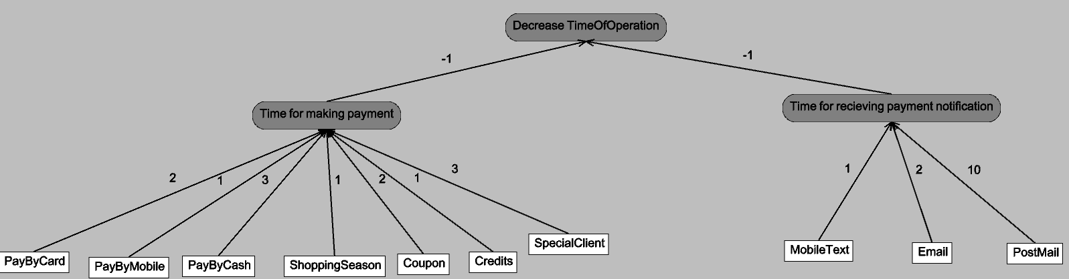

Getting a discount will definitely add to the time of making payment. However, if it’s Shopping season, everyone will be entitled to the discount, so it’s 1. Credits also will be automatically deducted from customer’s bill, so that’s also 1. Coupon requires some kind of coupon code. SpecialClient will require additional validation of the customer. Rest all weights and model seem self-explanatory.

1. **Increase Convenience**

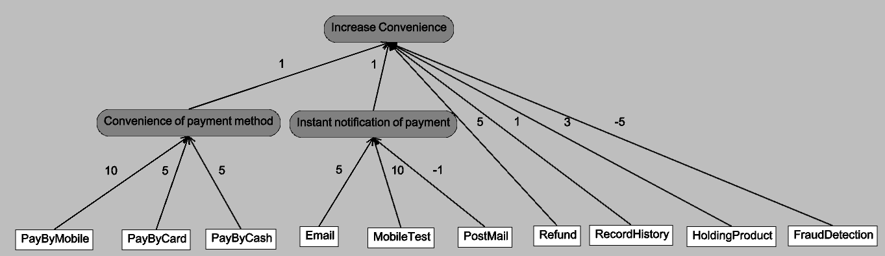

PayByMobile seems the most convenient method of payment because it doesn’t require a second level authentication (CVV, OTP etc) needed like card, and doesn’t require calculation and exchange of remaining “change” amount in card transaction.

Receiving an email would require internet connection, whereas text can be received anywhere with network connectivity. Post is definitely counter-productive to convenience, since it will be received days later. Refund, RecordHistory and HoldingProduct will all add to customer convenience, but FraudDetection will be hindrance in that.

1. **Increase Security**

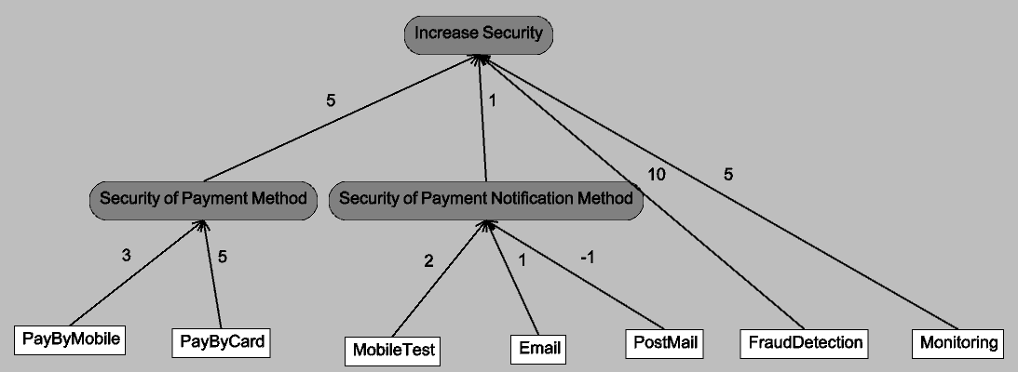

Security of Payment Notification means securing customer’s confidential information against hackers. Mobile text is the most difficult to intercept, an e-mail can be hacked more easily, and post is the easiest to intercept since it offers no kind of encryption (basically anyone can tear open the envelope and read the bill). In Security of Payment Method, we only consider card and mobile, since cash doesn’t possess any kind of digital security.

1. **Increase Trackability**

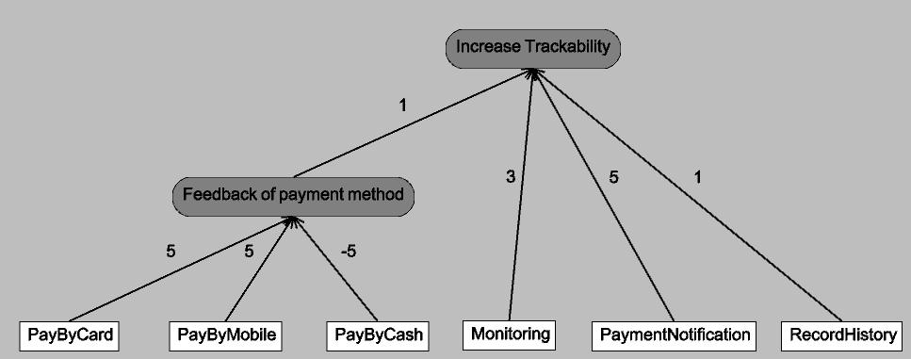

Cash method is very counter-productive in increasing Trackability since it leaves no digital trace of the transaction. Both card and mobile wallet leave similar trace of transaction (thus same weight). Payment Notification will be biggest proof of transaction completion, followed by Monitoring and then RecordHistory.